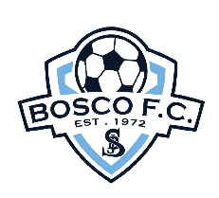Bosco FC Gala Night series 2024

Bosco FC warmly invites all U9 teams across the Sutherland Shire to participate in one of our annual gala nights:

Speedy Keys Cup – for all W9 grades (girls) – Friday 9 August
Bill Charlton Champions Cup – for U9 A & B grades (mixed/boys) – Friday 9 August
Jack Bird Trophy – for U9 C grade & below (mixed/boys) – Friday 16 August

IMPORTANT: Spots are limited and are expected to reach capacity. Entry will be on a first come, first served basis based on receipt of the form directly to Bosco FC.

Location: Woronora Heights Oval

Time: kick off at 5.30pm sharp. Each team is guaranteed four 20-minute games with the evening usually concluding after the final at about 8.30-9pm

Entry fee: $170 per team. Fee includes participation medal and sausage sizzle for all players. Once entry is confirmed, please deposit fee to Bosco FC, BSB: 062164, Account: 0090 2923

The canteen will be open. Further details will be provided to registered teams closer to the night.

For any enquiries, please email Meagan Battam at treasurer@boscofc.org.au

Register HERE

